-- Gen AI: Type of AI that can create new content similar to humans like images, music, text

-- Domains: Text - Text: Chat GPT, Text - Image: DALL-E

-- Use cases: content creation, Chatbots for customer support, Translation, Coding applications: Code understanding[what exactly code does], COde writing, Translations [ Java - Python ]

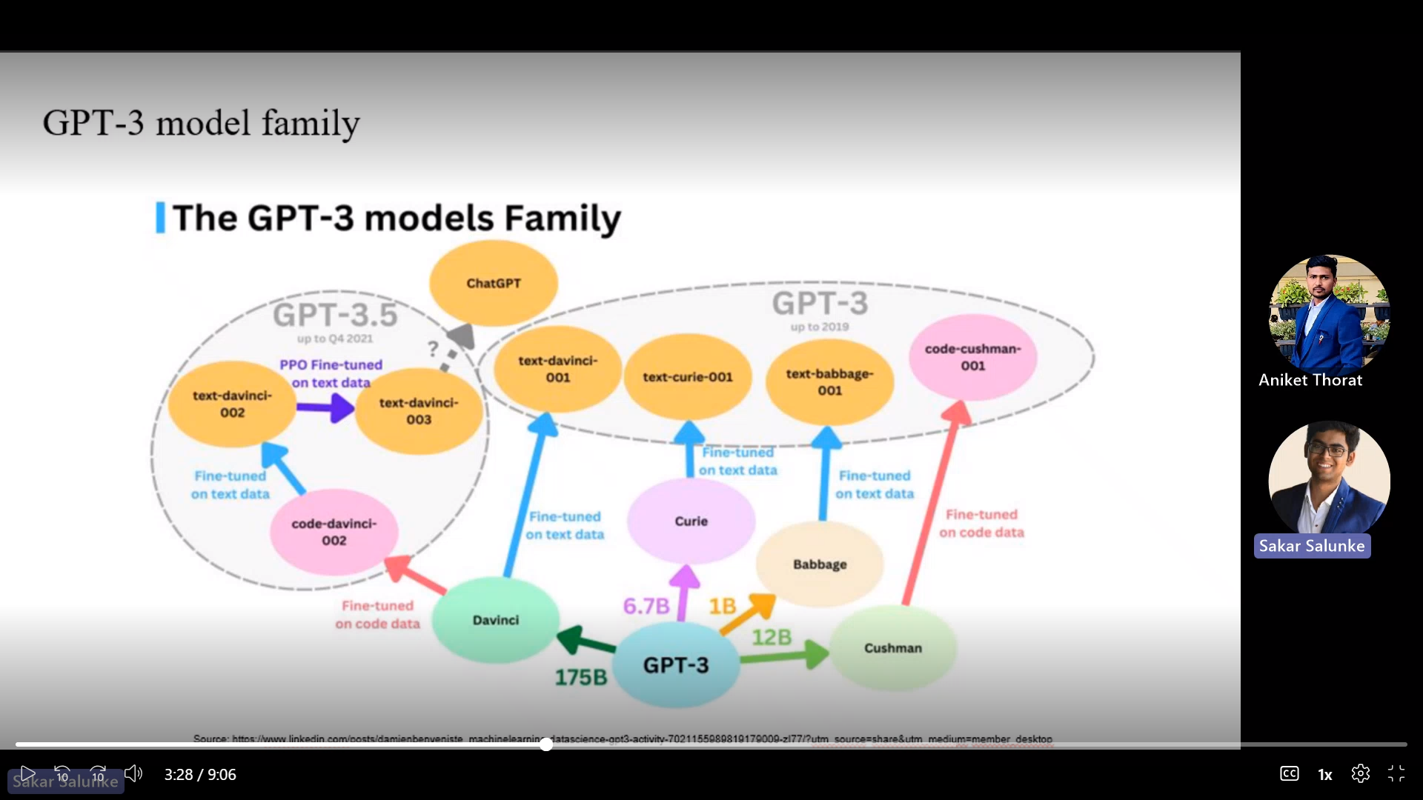

* GPT 3 is the baseline model

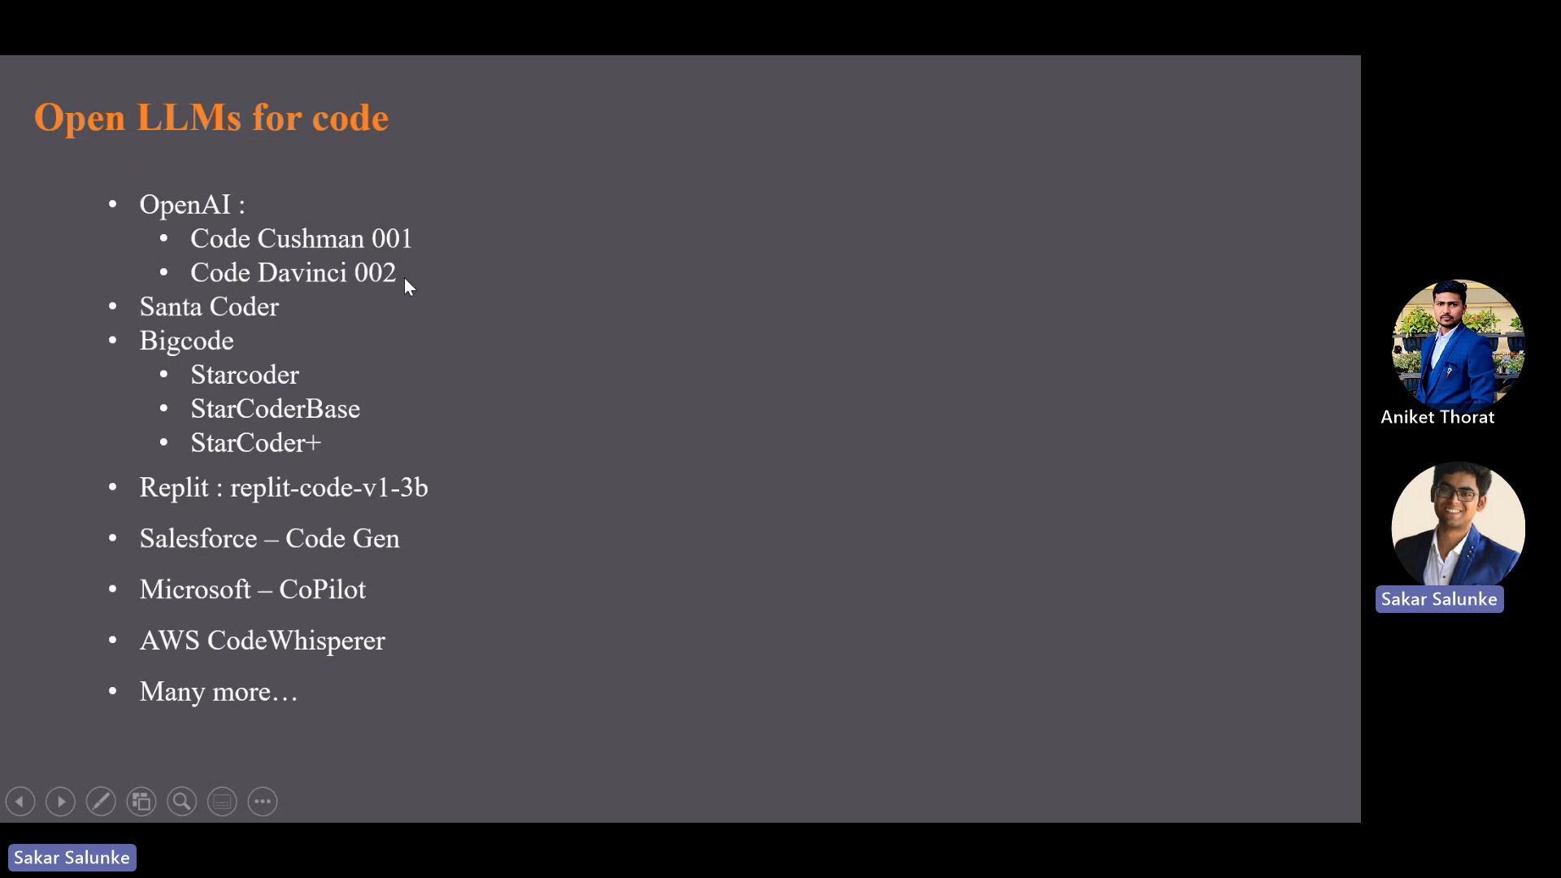

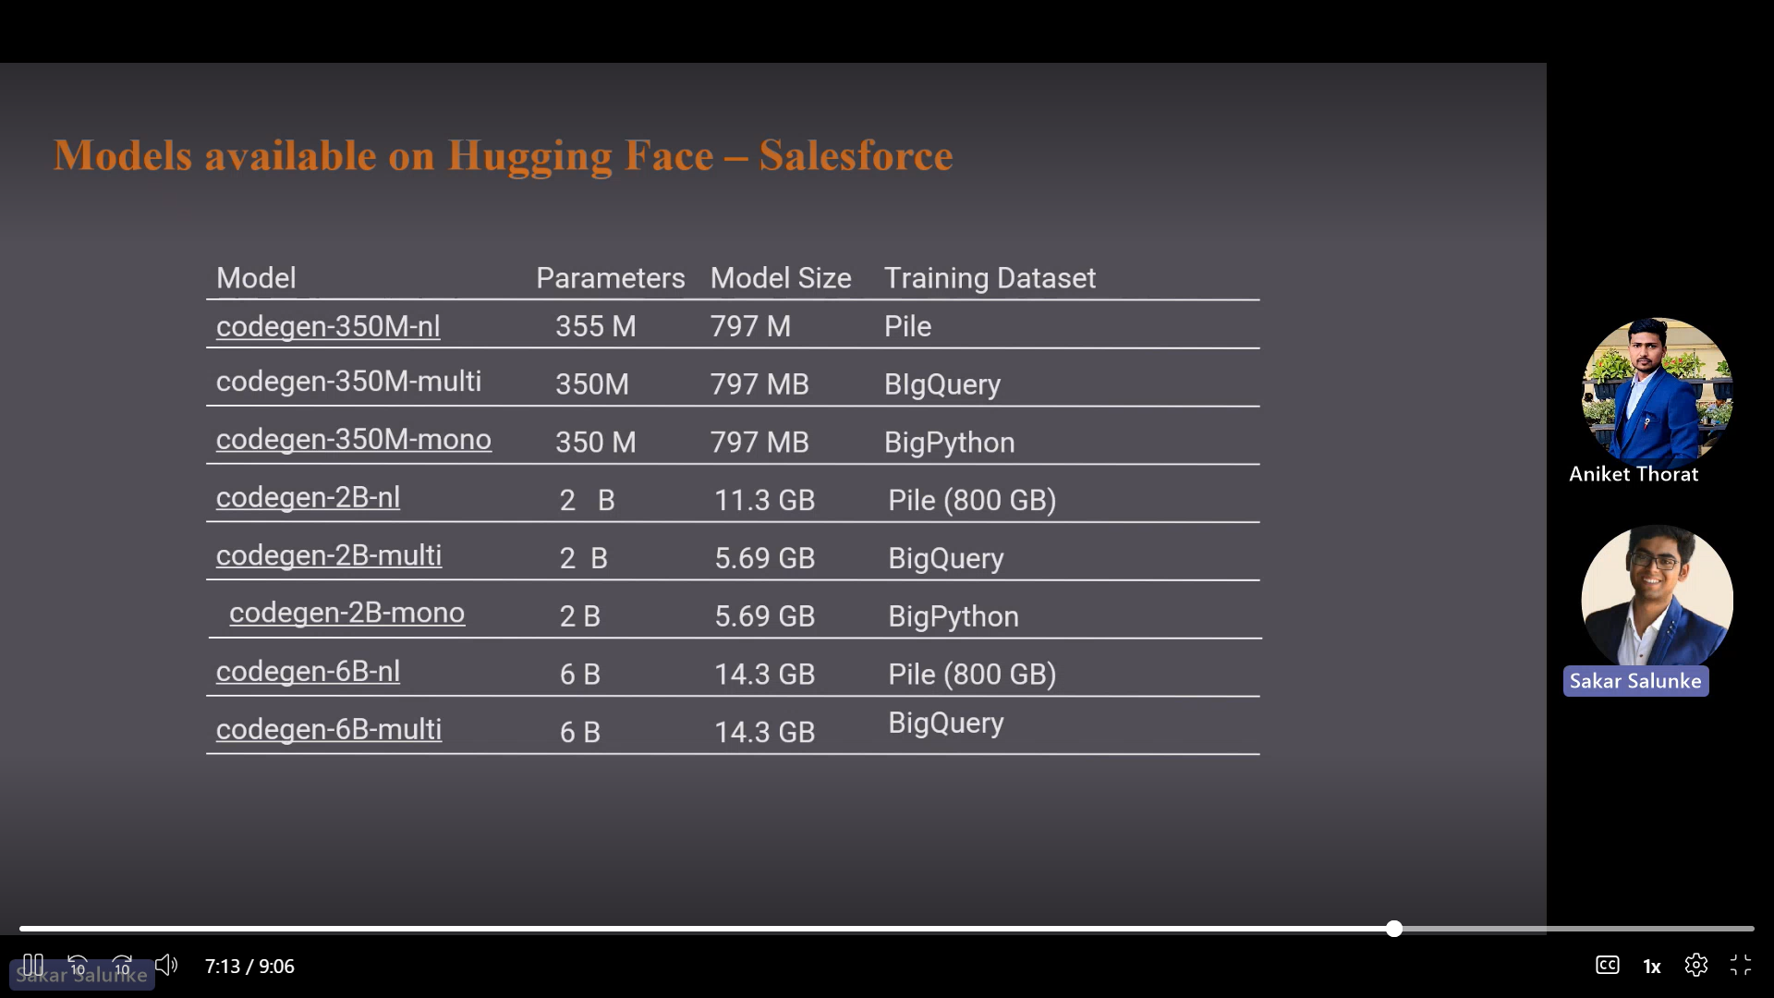

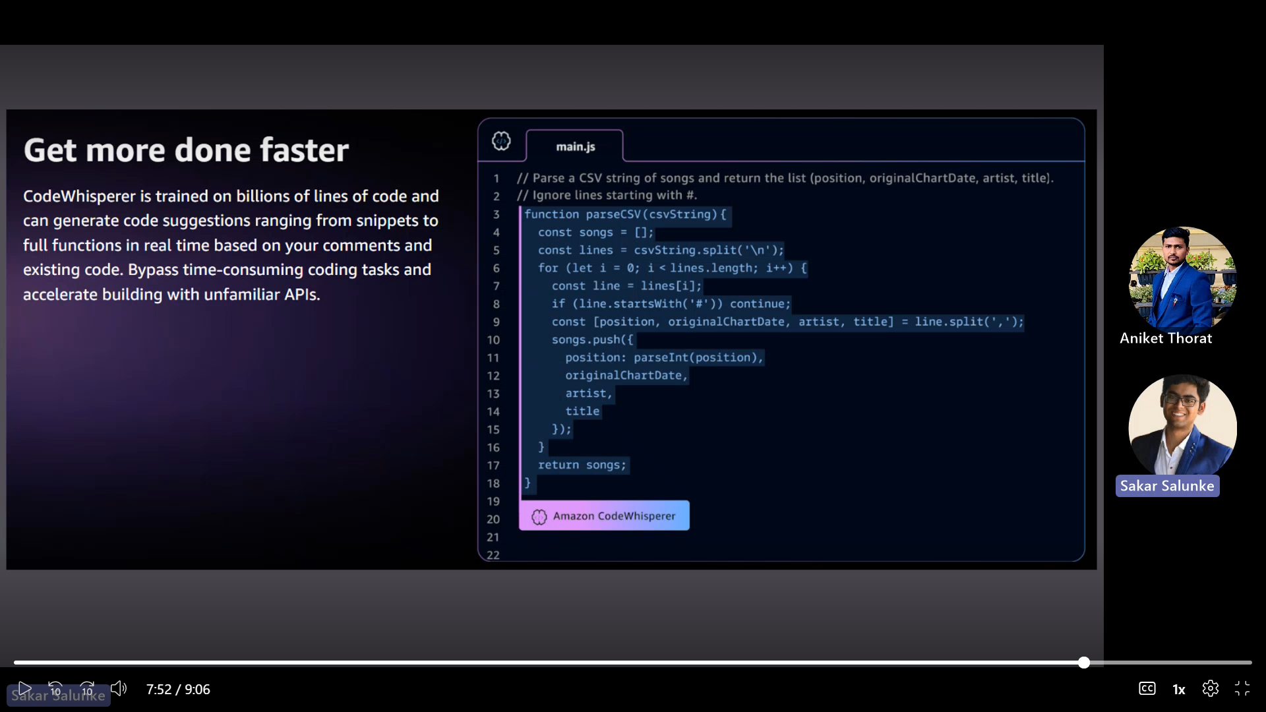

Generative AI can be a valuable tool in various stages of the software engineering life cycle. Here are some ways in which we can use generative AI:

Requirement Gathering:

Generative AI can help in the early stages of software development process by analyzing user feedback, natural language descriptions, and existing documentation to generate initial software requirements. This can help streamline the process and ensure that important aspects are not overlooked. Design and

Architecture:

Generative AI can aid in the design and architecture phase by auto generating code skeletons, class diagrams, and database schemas based on highlevel specifications. It can help software engineers explore different design possibilities and evaluate their feasibility.

Code Generation:

Generative AI can be used to automatically generate code snippets or complete modules based on specific requirements. This can speed up the development process, reduce human coding efforts, and enhance productivity. Generative AI models can learn from existing codebases to produce syntactically and semantically correct code.

Code Review and Refactoring:

Generative AI can help in code review and refactoring tasks. It can analyze existing codebases, identify potential issues such as code smells or performance bottlenecks, and propose refactoring suggestions. This can help improve code quality, maintainability, and performance.

Testing and Quality Assurance:

Generative AI can help in the generation of test cases and data sets for software testing. By analyzing existing test cases and code snippet, generative AI models can generate new test cases. It can also be used to automate the generation of synthetic data for testing different scenarios. Documentation: Generative AI can help automate the documentation process by generating code comments, API documentation and user manuals. By analyzing code structures and patterns, generative AI models can generate meaningful and accurate documentation, saving time and effort for developers.

Bug Detection and Resolution:

Generative AI can analyze codebases to identify bugs or vulnerabilities. By learning from historical data and patterns, generative AI models can warn about issues and suggest fixes or improvements. This can help improve code quality and reduce the likelihood of bugs or security vulnerabilities. It's important to note that while generative AI can be a powerful tool, it should not replace human expertise and judgment. It should be used as an help to support and improve the software development life cycle

**Prompt Types Explained**

1. **Zero-Shot Prompt**

A zero-shot prompt refers to providing a prompt or question to an AI model without any prior examples. The model is expected to generate a meaningful response based on its general knowledge and understanding of language. Essentially, it is one of the ways to test the model's reasoning ability and generate coherent answers even for unfamiliar prompts.

1. **One-Shot Prompting**

In prompt engineering, the technique used to generate prompts for AI language models is referred to as “one shot”. It involves providing a single example of the desired input-output behavior to guide the model's response. One shot prompting focuses on conveying the task or desired output through a concise single prompt. This technique leverages the model's ability to generalize from a single instance to generate coherent and contextually appropriate responses. One shot prompting can be useful in situations where the task can be properly conveyed through a single example or where providing multiple examples is impractical. It simplifies the prompt generation process while still allowing the model to produce meaningful outputs.

1. **Few-Shot Prompting**

When a prompt with a limited number of examples or demonstrations related to the desired task is given to an AI language model then that prompt is called as few-shot prompt. These examples are typically used to guide the model's understanding and assist it in generating a response. For example, in case of few-shot learning scenario, you might give the model a small set of text examples that demonstrate the desired behavior. The model can then leverage this limited set of examples to generate responses. Few-shot learning allows the model to generalize from a small amount of information and adapt its understanding to new or unseen inputs. It is particularly useful when there is limited training data available for a specific task.

**Best practices to follow while writing prompts**

1. A good prompt message should be clear, it should provide enough context to the model for generating the accurate code.
2. Mention the parameters that the function you define accepts.
3. Mention the format you want the model to return it's output in.
4. Instruct the model to generate code documentation.
5. Example for how you can describe your operation step by step.

[Prompt Engineering for Effective Interaction with ChatGPT - MachineLearningMastery.com](https://machinelearningmastery.com/prompt-engineering-for-effective-interaction-with-chatgpt/)

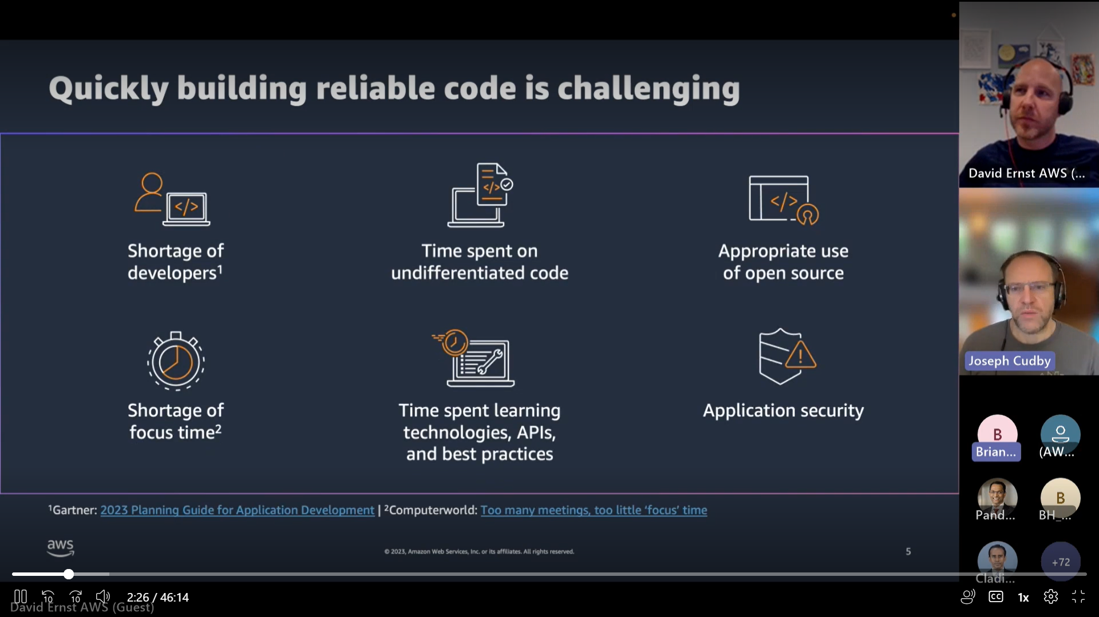

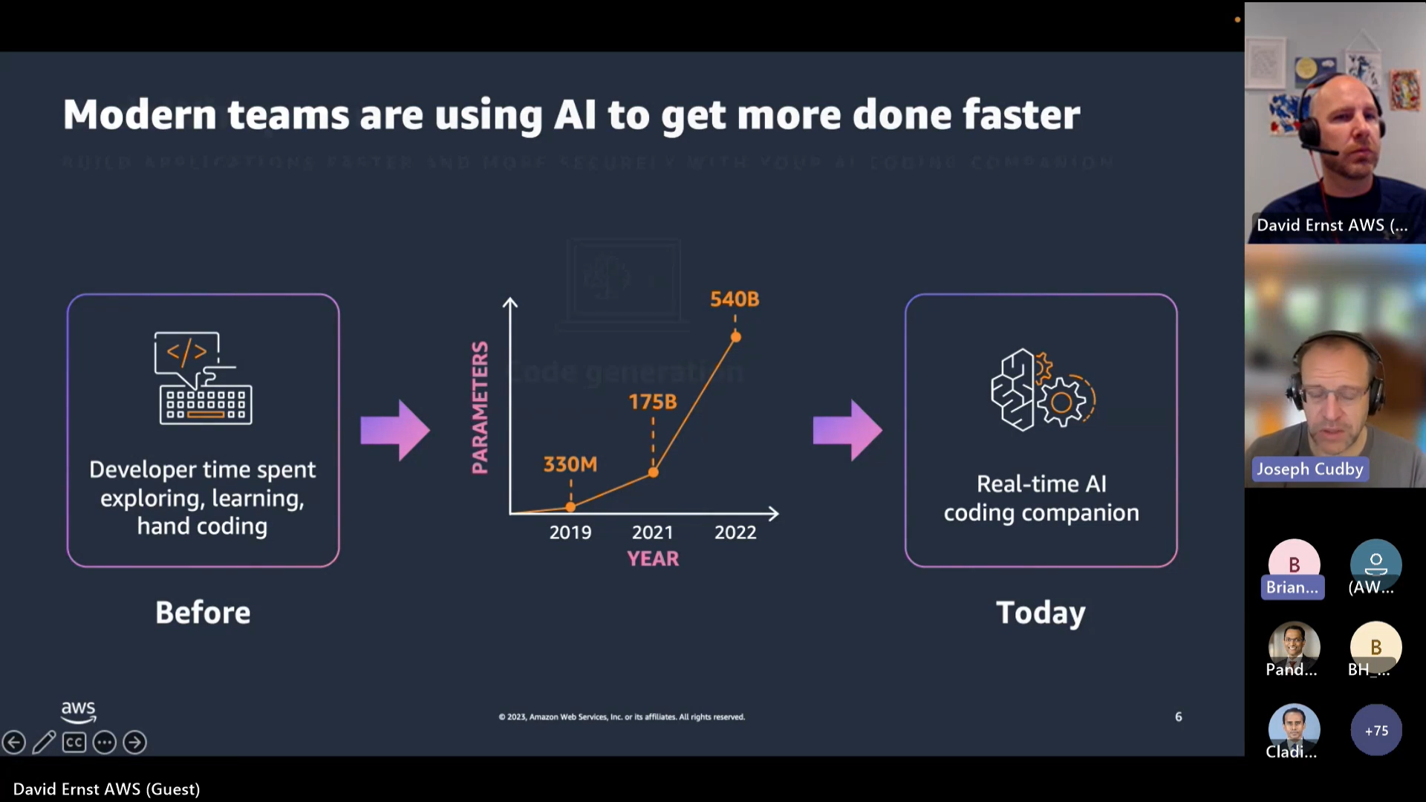

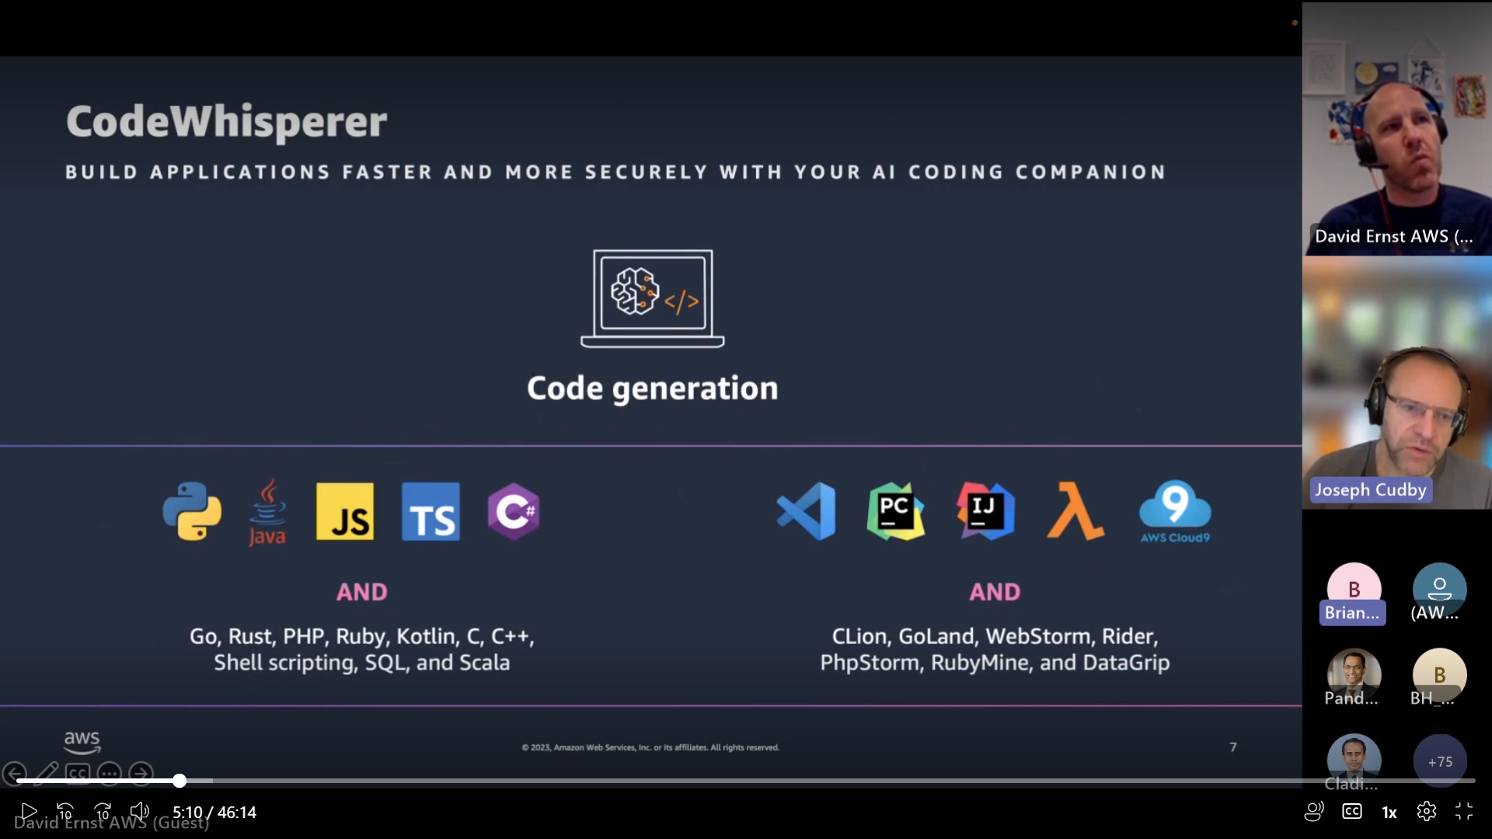

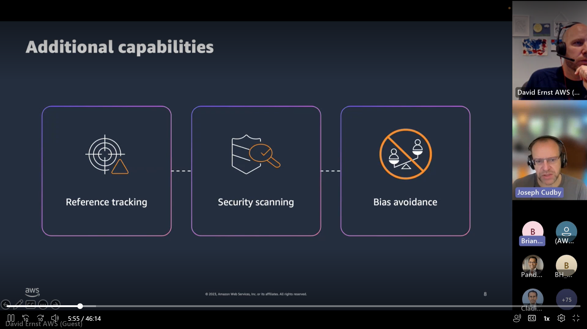

These are the differentiators

* Ref tracking is supported for the Top 5 languages (Multi line inputs). For the others it’s a single line completion
* Security scanning is not a replacement for enterprise security vulnerability solutions

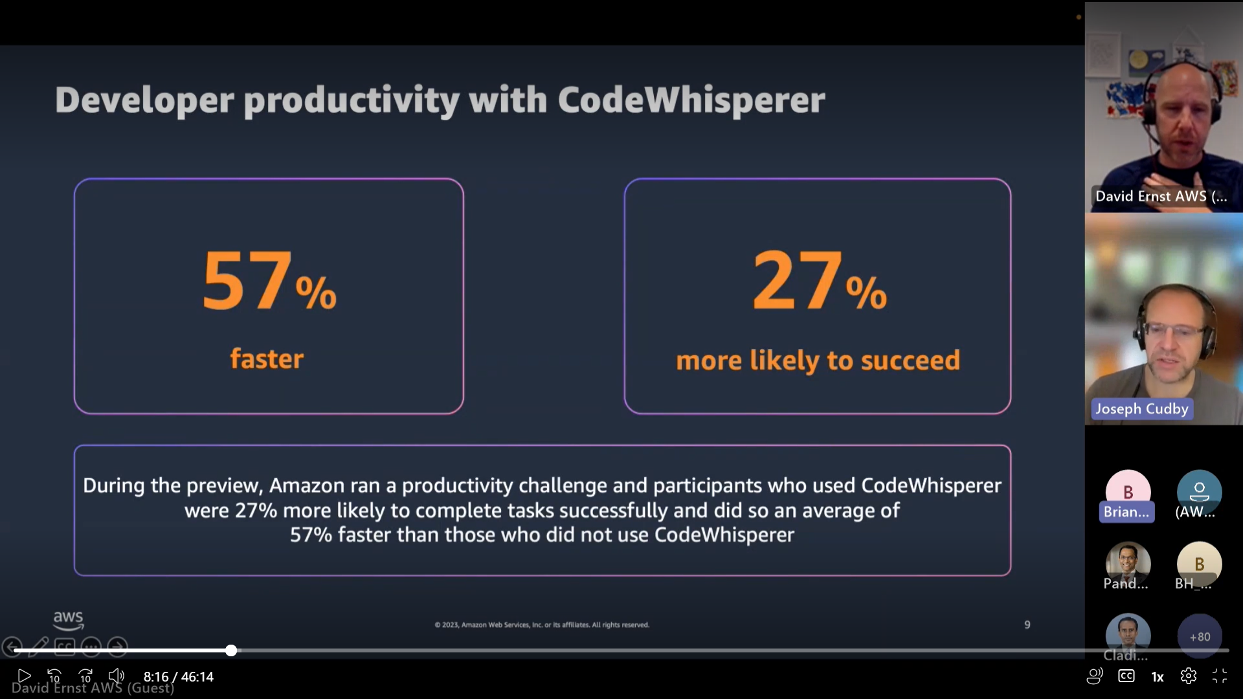

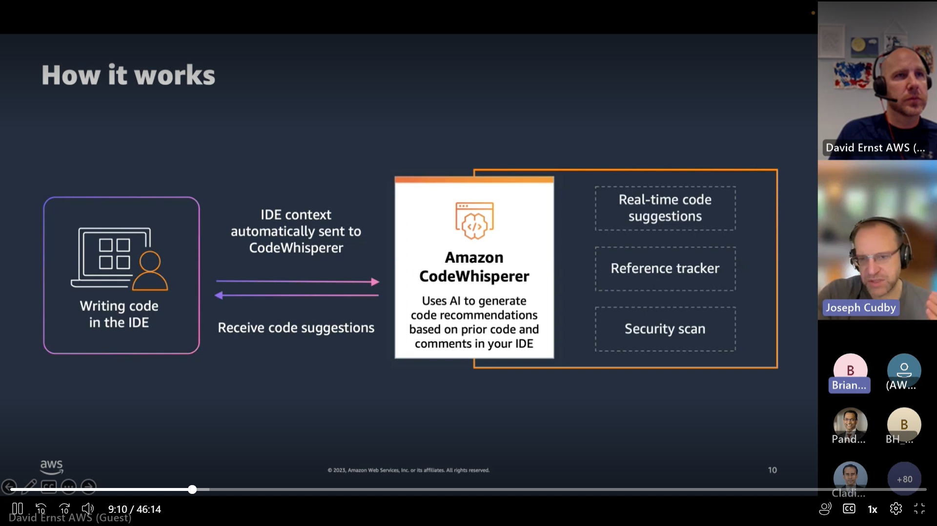

* Security scans can be run manually. 50 scans /month for CW individual, 500 for CW professional

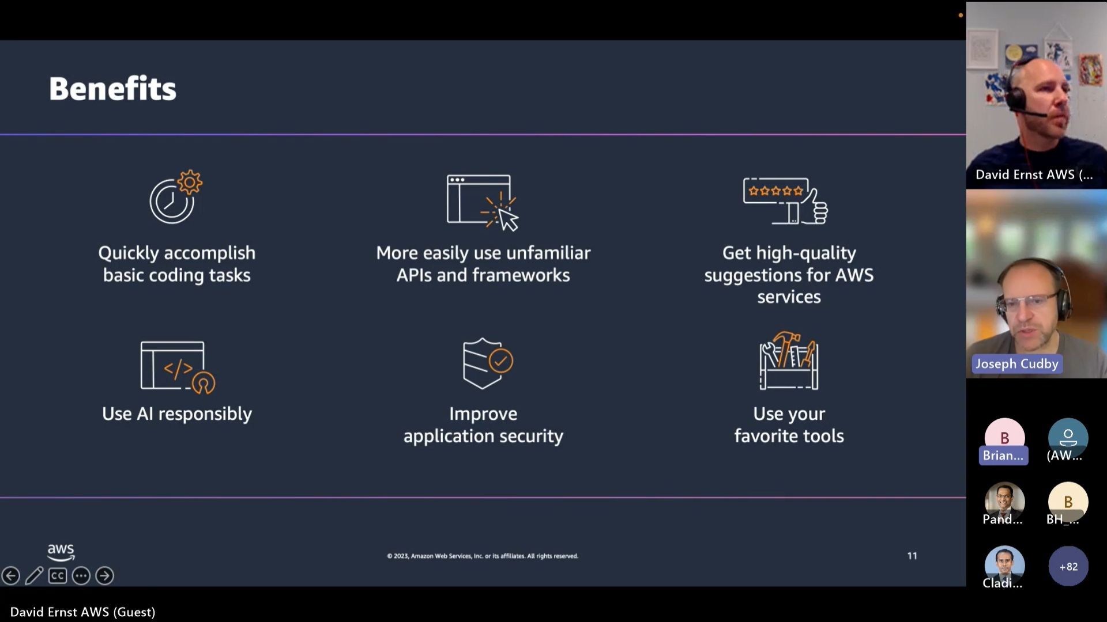

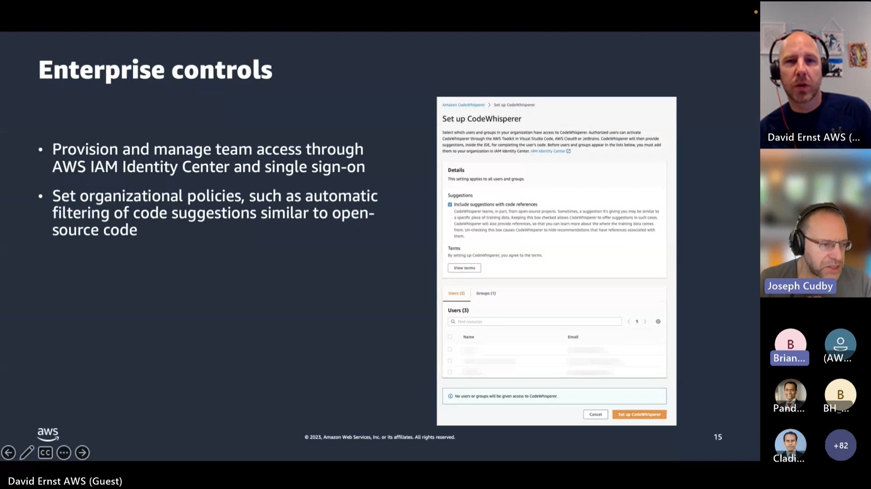

* For professional licenses, user can allow or reject code references thru console

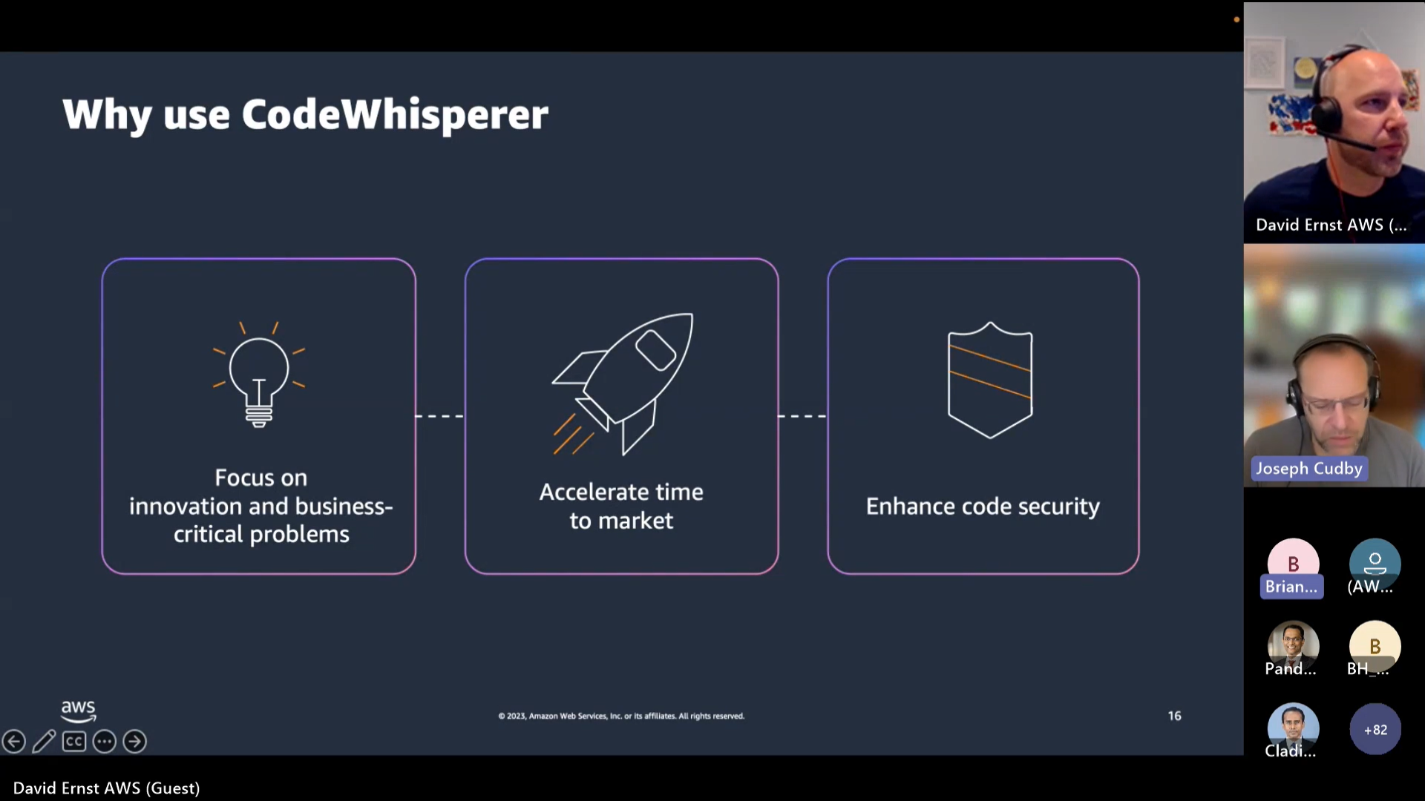

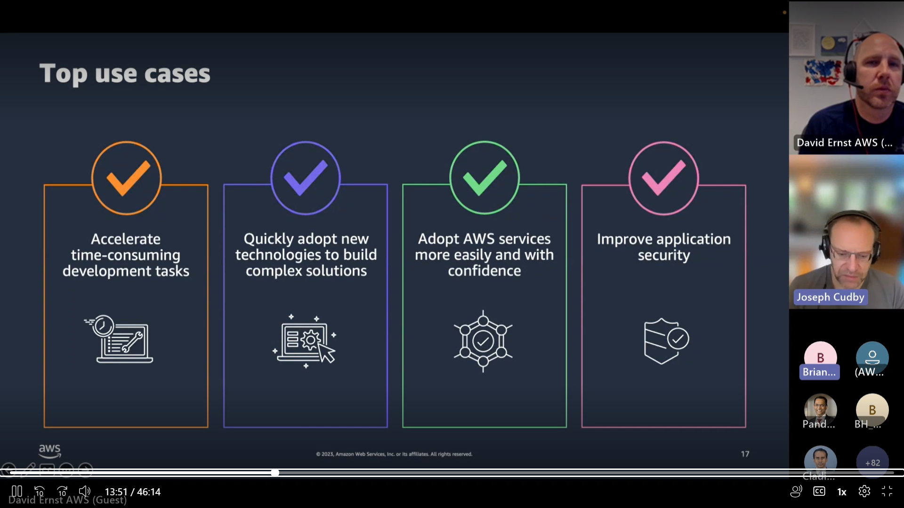

Enter to auto complete, tab to accept

CW may provide different results with two people providing the same prompt

Alt + C for forcing suggestions

Most popular supported languages - Java - Python - JavaScript - TypeScript - C# CodeWhisperer can generate multi line code for these languages

CW supports some more programming languages \ These are - Ruby - Go - PHP - C++ - C - Shell - Scala - Rust - Kotlin – SQL

CodeWhisperer generate one liner codes for these language

CW supports following IDEs

- Amazon Sagemaker Studio (a Web based IDE for ML workflows). Supported language is inly Python on this.

- JupyterLab (Open-Source Web based IDE that provides interactive environment for notebooks, code and data)

- Visual Studio Code (free extensible code editor from Microsoft. Most code available on GitHub under MIT license). CodeWhisperer runs on VSCode through AWS Toolkit which runs VS Code extension. VSCode supports all languages that CodeWhisperer supports. In some cases, you might be required to install a VS Code extension related to the language

- JetBrains (a software company that makes many IDEs). CodeWhisperer supports all IDEs from JetBrains except JetBrains Gateway

- Aws Cloud 9 (IDE that AWS offers as a service. You use it inside your web browser. You need AWS account)

- AWS Lambda (you can use CodeWhisperer to help you write Lambda functions)

Enter for suggestions, Alt + C to trigger CW suggestions manually, ESC to reject, tab to accept

<https://youtu.be/E0jCIPaIaiA> - CW live demo